***University Physics Volume I***

**Unit 1: Mechanics**

**Chapter 13: Gravitation**

**Conceptual Questions**

1. Action at a distance, such as is the case for gravity, was once thought to be illogical and therefore untrue. What is the ultimate determinant of the truth in science, and why was this action at a distance ultimately accepted?

Solution

The ultimate truth is experimental verification. Field theory was developed to help explain how force is exerted without objects being in contact for both gravity and electromagnetic forces that act at the speed of light. It has only been since the twentieth century that we have been able to measure that the force is not conveyed immediately.

1. In the law of universal gravitation, Newton assumed that the force was proportional to the product of the two masses (). While all scientific conjectures must be experimentally verified, can you provide arguments as to why this must be? (You may wish to consider simple examples in which any other form would lead to contradictory results.)

Solution

First, we argue that each mass must appear in the same form by symmetry. Second, if we imagine bringing a third mass, let’s say identical to the first one, then the force on that mass at an equal distance from the other mass must be the same. Hence, when we combine those two identical masses, the force must double. Only a simple product will give us that. The tacit assumption is that the third mass has no effect on the values of either of the other masses. Most consider this is a reasonable assumption, but it is an assumption.

1. Must engineers take Earth’s rotation into account when constructing very tall buildings at any location other than the equator or very near the poles?

Solution

The centripetal acceleration is not directed along the gravitational force and therefore the correct line of the building (i.e., the plumb bob line) is not directed towards the center of Earth. But engineers use either a plumb bob or a transit, both of which respond to both the direction of gravity and acceleration. No special consideration for their location on Earth need be made.

1. It was stated that a satellite with negative total energy is in a bound orbit, whereas one with zero or positive total energy is in an unbounded orbit. Why is this true? What choice for gravitational potential energy was made such that this is true?

Solution

Potential energy is arbitrary within a constant. For convenience, we have taken gravitational potential energy to be zero at infinity, and, hence, it is negative for any finite distance. Any object that reaches infinity and still has kinetic energy (which is always positive) will keep going. Any object with less kinetic energy than the absolute value of potential energy at any point, will always have negative total energy. Hence, its kinetic energy must go to zero before it reaches infinity, and gravity will always bring it back.

1. It was shown that the energy required to lift a satellite into a *low* Earth orbit (the change in potential energy) is only a small fraction of the kinetic energy needed to keep it in orbit. Is this true for larger orbits? Is there a trend to the ratio of kinetic energy to change in potential energy as the size of the orbit increases?

Solution

As we move to larger orbits, the change in potential energy increases, whereas the orbital velocity decreases. Hence, the ratio is highest near Earth’s surface (technically infinite if we orbit at Earth’s surface with no elevation change), moving to zero as we reach infinitely far away.

1. One student argues that a satellite in orbit is in free fall because the satellite keeps falling toward Earth. Another says a satellite in orbit is not in free fall because the acceleration due to gravity is not . With whom do you agree with and why?

Solution

The first student is correct. As the satellite falls, Earth’s surface curves away from the satellite due to the tangential speed. Free fall means simply that no force other than gravity is acting; it does not depend upon the value of *g*.

1. Many satellites are placed in geosynchronous orbits. What is special about these orbits? For a global communication network, how many of these satellites would be needed?

Solution

The period of the orbit must be 24 hours. But in addition, the satellite must be located in an equatorial orbit and orbiting in the same direction as Earth’s rotation. All three criteria must be met for the satellite to remain in one position relative to Earth’s surface. At least three satellites are needed, as two on opposite sides of Earth cannot communicate with each other. (This is not technically true, as a wavelength could be chosen that provides sufficient diffraction. But it would be totally impractical.)

1. Are Kepler’s laws purely descriptive, or do they contain causal information?

Solution

Kepler merely analyzed the data and stated what he observed from the data. It was Newton, aided by the work of a few before him, who showed that Kepler’s law arose naturally from the inverse square law of gravitation.

1. In the diagram below for a satellite in an elliptical orbit about a much larger mass, indicate where its speed is the greatest and where it is the least. What conservation law dictates this behavior? Indicate the directions of the force, acceleration, and velocity at these points. Draw vectors for these same three quantities at the two points where the *y*-axis intersects (along the semi-minor axis) and from this determine whether the speed is increasing decreasing, or at a max/min.

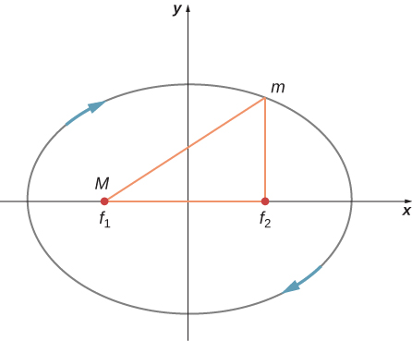

Solution

The speed is greatest where the satellite is closest to the large mass and least where farther away—at the periapsis and apoapsis, respectively. It is conservation of angular momentum that governs this relationship. But it can also be gleaned from conservation of energy, the kinetic energy must be greatest where the gravitational potential energy is the least (most negative). The force, and hence acceleration, is always directed towards *M* in the diagram, and the velocity is always tangent to the path at all points. The acceleration vector has a tangential component along the direction of the velocity at the upper location on the *y*-axis; hence, the satellite is speeding up. Just the opposite is true at the lower position.

1. As an object falls into a black hole, tidal forces increase. Will these tidal forces always tear the object apart as it approaches the Schwarzschild radius? How does the mass of the black hole and size of the object affect your answer?

Solution

The answer depends upon both the size of the object and the size of the black hole. If the black hole is very massive, and hence the radius is very large, then tidal forces need not be great. And the larger the object, the greater the distance from near and far sides, so the greater will be the tidal forces.

1. The principle of equivalence states that all experiments done in a lab in a uniform gravitational field cannot be distinguished from those done in a lab that is not in a gravitational field but is uniformly accelerating. For the latter case, consider what happens to a laser beam at some height shot perfectly horizontally to the floor, across the accelerating lab. (View this from a nonaccelerating frame outside the lab.) Relative to the height of the laser, where will the laser beam hit the far wall? What does this say about the effect of a gravitational field on light? Does the fact that light has no mass make any difference to the argument?

Solution

The laser beam will hit the far wall at a lower elevation than it left, as the floor is accelerating upward. Relative to the lab, the laser beam “falls.” So we would expect this to happen in a gravitational field. The mass of light, or even an object with mass, is not relevant.

1. As a person approaches the Schwarzschild radius of a black hole, outside observers see all the processes of that person (their clocks, their heart rate, etc.) slowing down, and coming to a halt as they reach the Schwarzschild radius. (The person falling into the black hole sees their own processes unaffected.) But the speed of light is the same everywhere for all observers. What does this say about space as you approach the black hole?

Solution

The space is being stretched more and more as we approach the black hole, so as the person approaches, the light has farther and farther to travel to the observers. We never see them cross the Schwarzschild radius since the space stretches to infinity there.

**Problems**

1. Evaluate the magnitude of gravitational force between two 5-kg spherical steel balls separated by a center-to-center distance of 15 cm.

Solution



1. Estimate the gravitational force between two sumo wrestlers, with masses 220 kg and 240 kg, when they are embraced and their centers are 1.2 m apart.

Solution



1. Astrology makes much of the position of the planets at the moment of one’s birth. The only known force a planet exerts on Earth is gravitational. (a) Calculate the gravitational force exerted on a 4.20-kg baby by a 100-kg father 0.200 m away at birth (he is assisting, so he is close to the child). (b) Calculate the force on the baby due to Jupiter if it is at its closest distance to Earth, some  away. How does the force of Jupiter on the baby compare to the force of the father on the baby? Other objects in the room and the hospital building also exert similar gravitational forces. (Of course, there could be an unknown force acting, but scientists first need to be convinced that there is even an effect, much less that an unknown force causes it.)

Solution

a. ; b. The mass of Jupiter is

1. A mountain 10.0 km from a person exerts a gravitational force on him equal to 2.00% of his weight. (a) Calculate the mass of the mountain. (b) Compare the mountain’s mass with that of Earth. (c) What is unreasonable about these results? (d) Which premises are unreasonable or inconsistent? (Note that accurate gravitational measurements can easily detect the effect of nearby mountains and variations in local geology.)

Solution

a. ; b. ; c. That is an enormous mass for one mountain, and its fraction of the earth’s mass is too large. d. The unreasonable premise is that the mountain exerts a gravitational force equal to 2.00% of the person’s weight.

1. The International Space Station has a mass of approximately 370,000 kg. (a) What is the force on a 150-kg suited astronaut if she is 20 m from the center of mass of the station? (b) How accurate do you think your answer would be?

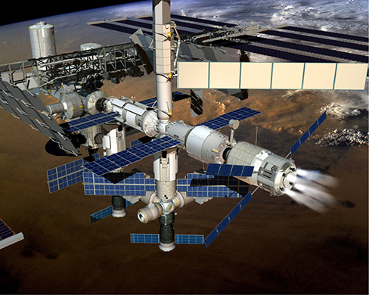

Solution

a. ; b. Not very, as the ISS is not even symmetrical, much less spherically symmetrical.

1. Asteroid Toutatis passed near Earth in 2006 at four times the distance to our Moon. This was the closest approach we will have until 2060. If it has mass of , what force did it exert on Earth at its closest approach?

Solution



1. (a) What was the acceleration of Earth caused by asteroid Toutatis (see previous problem) at its closest approach? (b) What was the acceleration of Toutatis at this point?

Solution

a. ; b. 

1. (a) Calculate Earth’s mass given the acceleration due to gravity at the North Pole is measured to be  and the radius of the Earth at the pole is 6356 km. (b) Compare this with the NASA’s Earth Fact Sheet value of 

Solution

a. ; b. This is smaller than the NASA value by about 0.3%.

1. (a) What is the acceleration due to gravity on the surface of the Moon? (b) On the surface of Mars? The mass of Mars is  and its radius is .

Solution

a. ; b. 

1. (a) Calculate the acceleration due to gravity on the surface of the Sun. (b) By what factor would your weight increase if you could stand on the Sun? (Never mind that you cannot.)

Solution

a. ; b. 28.0 times

1. The mass of a particle is 15 kg. (a) What is its weight on Earth? (b) What is its weight on the Moon? (c) What is its mass on the Moon? (d) What is its weight in outer space far from any celestial body? (e) What is its mass at this point?

Solution

a. 147 N; b. 25.5 N; c. 15 kg; d. 0; e. 15 kg

1. On a planet whose radius is  the acceleration due to gravity is  What is the mass of the planet?

Solution



1. The mean diameter of the planet Saturn is  and its mean mass density is  Find the acceleration due to gravity at Saturn’s surface.

Solution



1. The mean diameter of the planet Mercury is  and the acceleration due to gravity at its surface is  Estimate the mass of this planet.

Solution



1. The acceleration due to gravity on the surface of a planet is three times as large as it is on the surface of Earth. The mass density of the planet is known to be twice that of Earth. What is the radius of this planet in terms of Earth’s radius?

Solution



1. A body on the surface of a planet with the same radius as Earth’s weighs 10 times more than it does on Earth. What is the mass of this planet in terms of Earth’s mass?

Solution



1. Find the escape speed of a projectile from the surface of Mars.

Solution

5000 m/s

1. Find the escape speed of a projectile from the surface of Jupiter.

Solution

60,300 m/s

1. What is the escape speed of a satellite located at the Moon’s orbit about Earth? Assume the Moon is not nearby.

Solution

1440 m/s

1. (a) Evaluate the gravitational potential energy between two 5.00-kg spherical steel balls separated by a center-to-center distance of 15.0 cm. (b) Assuming that they are both initially at rest relative to each other in deep space, use conservation of energy to find how fast will they be traveling upon impact. Each sphere has a radius of 5.10 cm.

Solution

a. ; b. 

1. An average-sized asteroid located  from Earth with mass  is detected headed directly toward Earth with speed of 2.0 km/s. What will its speed be just before it hits our atmosphere? (You may ignore the size of the asteroid.)

Solution

11 km/s

1. (a) What will be the kinetic energy of the asteroid in the previous problem just before it hits Earth? b) Compare this energy to the output of the largest fission bomb, 2100 TJ. What impact would this have on Earth?

Solution

a. ; b. over 600,000 times more energy in the asteroid, clearly a tremendous impact

1. (a) What is the change in energy of a 1000-kg payload taken from rest at the surface of Earth and placed at rest on the surface of the Moon? (b) What would be the answer if the payload were taken from the Moon’s surface to Earth? Is this a reasonable calculation of the energy needed to move a payload back and forth?

Solution

a. ; b. ; No. It assumes the kinetic energy is recoverable. This would not even be reasonable if we had an elevator between Earth and the Moon.

1. If a planet with 1.5 times the mass of Earth was traveling in Earth’s orbit, what would its period be?

Solution

1 yr

1. Two planets in circular orbits around a star have speeds of *v* and 2*v*. (a) What is the ratio of the orbital radii of the planets? (b) What is the ratio of their periods?

Solution

a. 0.25; b. 0.125

1. Using the average distance of Earth from the Sun, and the orbital period of Earth, (a) ﬁnd the centripetal acceleration of Earth in its motion about the Sun. (b) Compare this value to that of the centripetal acceleration at the equator due to Earth’s rotation.

Solution

a. ; b. From Gravitation Near Earth’s Surface, we have  at the equator, so it is over five times greater.

1. (a) What is the orbital radius of an Earth satellite having a period of 1.00 h? (b) What is unreasonable about this result?

Solution

a. ; b. This less than the radius of Earth.

1. Calculate the mass of the Sun based on data for Earth’s orbit and compare the value obtained with the Sun’s actual mass.

Solution



1. Find the mass of Jupiter based on the fact that Io, its innermost moon, has an average orbital radius of 421,700 km and a period of 1.77 days.

Solution



1. Astronomical observations of light from our Milky Way galaxy’s stars indicate that it has a mass of about  solar masses. A star orbiting on the galaxy’s periphery is about  light-years from its center. (a) What should the orbital period of that star be? (b) If its period is  years instead, what is the mass of the galaxy? Such calculations are used to imply the existence of mass that does not emit any light. Scientists do not what it is comprised of, so this mass is known simply as "dark matter" and remains an enduring astronomical mystery.

Solution

a.  b. solar masses

1. (a) In order to keep a small satellite from drifting into a nearby asteroid, it is placed in orbit with a period of 3.02 hours and radius of 2.0 km. What is the mass of the asteroid? (b) Does this mass seem reasonable for the size of the orbit?

Solution

a. ; b. The satellite must be outside the radius of the asteroid, so it can’t be larger than this. If it were this size, then its density would be about . This is just above that of water, so this seems quite reasonable.

1. The Moon and Earth rotate about their common center of mass, which is located about 4700 km from the center of Earth. (This is 1690 km below the surface.) (a) Calculate the acceleration due to the Moon’s gravity at that point. (b) Calculate the centripetal acceleration of the center of Earth as it rotates about that point once each lunar month (about 27.3 d) and compare it with the acceleration found in part (a). Comment on whether or not they are equal and why they should or should not be.

Solution

a. ; b. ; The values are nearly identical. We would expect the gravitational force to be the same as the centripetal force at the core of the system. *(Note: These values may be close, but if students are to use the gravitational force to find the acceleration in a), the distance used should be between the c.o.m of Earth and the Moon, not to the c.o.m of the system.)*

1. The Sun orbits the Milky Way galaxy once each  with a roughly circular orbit averaging a radius of light-years. (A light-year is the distance traveled by light in 1 year.) Calculate the centripetal acceleration of the Sun in its galactic orbit. Does your result support the contention that a nearly inertial frame of reference can be located at the Sun? (b) Calculate the average speed of the Sun in its galactic orbit. Does the answer surprise you?

Solution

a. ; Yes, the centripetal acceleration is so small it supports the contention that a nearly inertial frame of reference can be located at the Sun. b. 

1. A geosynchronous Earth satellite is one that has an orbital period of precisely 1 day. Such orbits are useful for communication and weather observation because the satellite remains above the same point on Earth (provided it orbits in the equatorial plane in the same direction as Earth’s rotation). Calculate the radius of such an orbit based on the data for Earth in Appendix D.

Solution



1. Calculate the mass of the Sun based on data for average Earth’s orbit and compare the value obtained with the Sun’s commonly listed value of 

Solution

 The values are the same within 0.05%.

1. Io orbits Jupiter with an average radius of 421,700 km and a period of 1.769 days. Based upon these data, what is the mass of Jupiter?

Solution



1. The “mean” orbital radius listed for astronomical objects orbiting the Sun is typically not an integrated average but is calculated such that it gives the correct period when applied to the equation for circular orbits. Given that, what is the mean orbital radius in terms of aphelion and perihelion?

Solution

Compare  and  to see that they differ only in that the circular radius, *r*, is replaced by the semi-major axis, *a*. Therefore, the mean radius is one-half the sum of the aphelion and perihelion, the same as the semi-major axis.

1. The perihelion of Halley’s Comet is 0.586 AU and the aphelion is 17.8 AU. Given that its speed at perihelion is 55 km/s, what is the speed at aphelion ? (*Hint:* You may use either conservation of energy or angular momentum, but the latter is much easier.)

Solution

1.8 km/s

1. The perihelion of the comet Lagerkvist is 2.61 AU and it has a period of 7.36 years. Show that the aphelion for this comet is 4.95 AU.

Solution

The semi-major axis, 3.78 AU is found from the equation for the period. This is one-half the sum of the aphelion and perihelion, giving an aphelion distance of 4.95 AU.

1. What is the ratio of the speed at perihelion to that at aphelion for the comet Lagerkvist in the previous problem?

Solution

The ratio of the speeds is the inverse of the distances, so 1.90.

1. Eros has an elliptical orbit about the Sun, with a perihelion distance of 1.13 AU and aphelion distance of 1.78 AU. What is the period of its orbit?

Solution

1.75 years

1. (a) What is the difference between the forces on a 1.0-kg mass on the near side of Io and far side due to Jupiter? Io has a mean radius of 1821 km and a mean orbital radius about Jupiter of 421,700 km. (b) Compare this difference to that calculated for the difference for Earth due to the Moon calculated in Example: “Comparing Tidal Forces”. Tidal forces are the cause of Io’s volcanic activity.

Solution

a. 0.755 N near side vs. 0.742 N for a difference of 0.013 N; b. The difference for Earth’s tidal forces due to the Moon was about , so the difference in gravitational force for Io is nearly 6000 times that of Earth.

1. If the Sun were to collapse into a black hole, the point of no return for an investigator would be approximately 3 km from the center singularity. Would the investigator be able to survive visiting even 300 km from the center? Answer this by finding the difference in the gravitational attraction the black holes exerts on a 1.0-kg mass at the head and at the feet of the investigator.

Solution

19,800 N; this is clearly not survivable

1. Consider the following figure from Tidal Forces. This diagram represents the tidal forces for spring tides. Sketch a similar diagram for neap tides. (*Hint:* For simplicity, imagine that the Sun and the Moon contribute equally. Your diagram would be the vector sum of two force fields (as in the following figure), reduced by a factor of two, and superimposed at right angles.)

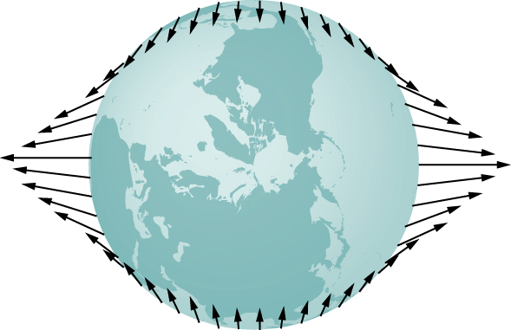

Solution

The diagram would have smaller, but not zero, bulges and four bulges instead of two.

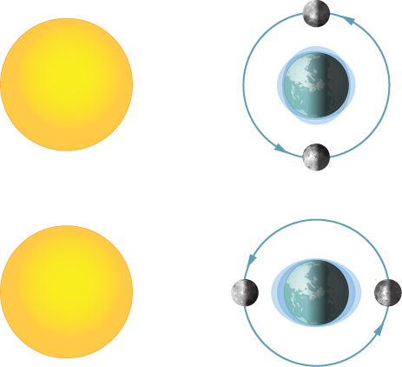

1. What is the Schwarzschild radius for the black hole at the center of our galaxy if it has the mass of 4 million solar masses?

Solution



1. What would be the Schwarzschild radius, in light years, if our Milky Way galaxy of 100 billion stars collapsed into a black hole? Compare this to our distance from the center, about 13,000 light years.

Solution

 which is about 0.374 light-years, so much smaller than our distance to the center

**Additional Problems**

1. A neutron star is a cold, collapsed star with nuclear density. A particular neutron star has a mass twice that of our Sun with a radius of 12.0 km. (a) What would be the weight of a 100-kg astronaut on standing on its surface? (b) What does this tell us about landing on a neutron star?

Solution

a. ; b. Don’t do it!

1. (a) How far from the center of Earth would the net gravitational force of Earth and the Moon on an object be zero? (b) Setting the *magnitudes* of the forces equal should result in two answers from the quadratic. Do you understand why there are two positions, but only one where the net force is zero?

Solution

a.  b) You get  from the square root, and the negative root gives the distance on the other side where the magnitudes are equal but in the same direction.

1. How far from the center of the Sun would the net gravitational force of Earth and the Sun on a spaceship be zero?

Solution



1. Calculate the values of *g* at Earth’s surface for the following changes in Earth’s properties: (a) its mass is doubled and its radius is halved; (b) its mass density is doubled and its radius is unchanged; (c) its mass density is halved and its mass is unchanged.

Solution

a.  b.  c. 

1. Suppose you can communicate with the inhabitants of a planet in another solar system. They tell you that on their planet, whose diameter and mass are  and  respectively, the record for the high jump is 2.0 m. Given that this record is close to 2.4 m on Earth, what would you conclude about your extraterrestrial friends’ jumping ability?

Solution

The value of *g* for this planet is 3.8 m/s2, which is about one-fourth that of Earth. So they are weak high jumpers.

1. (a) Suppose that your measured weight at the equator is one-half your measured weight at the pole on a planet whose mass and diameter are equal to those of Earth. What is the rotational period of the planet? (b) Would you need to take the shape of this planet into account?

Solution

a.  b. This is an incredible rotation rate that would severely distort the shape of the planet, and you would need to account for that shape in this calculation.

1. A body of mass 100 kg is weighed at the North Pole and at the equator with a spring scale. What is the scale reading at these two points? Assume that  at the pole.

Solution

At the North Pole, 983 N; at the equator, 980 N

1. Find the speed needed to escape from the solar system starting from the surface of Earth. Assume there are no other bodies involved and do not account for the fact that Earth is moving in its orbit. [*Hint:*  does not apply. Use  and include the potential energy of both Earth and the Sun.]

Solution

43.6 km/s

1. Consider the previous problem and include the fact that Earth has an orbital speed about the Sun of 29.8 km/s. (a) What speed relative to Earth would be needed and in what direction should you leave Earth? (b) What will be the shape of the trajectory?

Solution

a. The escape velocity is still 43.6 km/s. By launching from Earth in the direction of Earth’s tangential velocity, you need  relative to Earth. b. The total energy is zero and the trajectory is a parabola.

1. A comet is observed 1.50 AU from the Sun with a speed of 24.3 km/s. Is this comet in a bound or unbound orbit?

Solution

The total energy is  per unit mass, so that would be a bound orbit.

1. An asteroid has speed 15.5 km/s when it is located 2.00 AU from the sun. At its closest approach, it is 0.400 AU from the Sun. What is its speed at that point?

Solution

61.5 km/s

1. Space debris left from old satellites and their launchers is becoming a hazard to other satellites. (a) Calculate the speed of a satellite in an orbit 900 km above Earth’s surface. (b) Suppose a loose rivet is in an orbit of the same radius that intersects the satellite’s orbit at an angle of  What is the velocity of the rivet relative to the satellite just before striking it? (c) If its mass is 0.500 g, and it comes to rest inside the satellite, how much energy in joules is generated by the collision? (Assume the satellite’s velocity does not change appreciably, because its mass is much greater than the rivet’s.)

Solution

a. ; b.

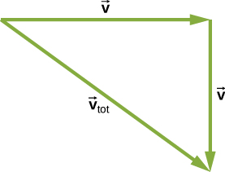

In the satellite’s frame of reference, the rivet has two perpendicular velocity components equal to *v* from part (a):  c. 

1. A satellite of mass 1000 kg is in circular orbit about Earth. The radius of the orbit of the satellite is equal to two times the radius of Earth. (a) How far away is the satellite? (b) Find the kinetic, potential, and total energies of the satellite.

Solution

a.  b. **

1. After Ceres was promoted to a dwarf planet, we now recognize the largest known asteroid to be Vesta, with a mass of  and a diameter ranging from 578 km to 458 km. Assuming that Vesta is spherical with a diameter of 520 km, find the approximate escape velocity from its surface.

Solution

370 m/s

1. (a) Given the asteroid Vesta which has a diameter of 520 km and mass of , what would be the orbital period for a space probe in a circular orbit of 10.0 km from its surface? (b) Why is this calculation marginally useful at best?

Solution

a.  or about 1.8 hours. This was using the 520 km average diameter. b. Vesta is clearly not very spherical, so you would need to be above the largest dimension, nearly 580 km. More importantly, the nonspherical nature would disturb the orbit very quickly, so this calculation would not be very accurate even for one orbit.

1. What is the orbital velocity of our solar system about the center of the Milky Way? Assume that the mass within a sphere of radius equal to our distance away from the center is about a 100 billion solar masses. Our distance from the center is 27,000 light years.

Solution

228 km/s

1. (a) Using the information in the previous problem, what velocity do you need to escape the Milky Way galaxy from our present position? (b) Would you need to accelerate a spaceship to this speed relative to Earth?

Solution

a. 323 km/s; b. No, you need only the difference between the solar system’s orbital speed and escape speed, so about 

1. Circular orbits in  for conic sections must have eccentricity zero. From this, and using Newton’s second law applied to centripetal acceleration, show that the value of  in  is given by  where *L* is the angular momentum of the orbiting body. The value of  is constant and given by this expression regardless of the type of orbit.

Solution

Use the definition of angular momentum () and 

1. Show that for eccentricity equal to one in  for conic sections, the path is a parabola. Do this by substituting Cartesian coordinates, *x* and *y*, for the polar coordinates, *r* and  and showing that it has the general form for a parabola, 

Solution

Setting  in  we have ; hence,  Expand and collect to show 

1. Using the technique shown in Satellite Orbits and Energy, show that two masses  and  in circular orbits about their common center of mass, will have total energy  We have shown the kinetic energy of both masses explicitly. (*Hint:* The masses orbit at radii  and , respectively, where . Be sure not to confuse the radius needed for centripetal acceleration with that for the gravitational force.)

Solution

Relating the gravitation force to the centripetal acceleration for each, we have the first mass  Substitute for the kinetic energy for each respectively and factor to get the result.

1. Given the perihelion distance, *p*, and aphelion distance, *q*, for an elliptical orbit, show that the velocity at perihelion, , is given by  (*Hint:* Use conservation of angular momentum to relate  and , and then substitute into the conservation of energy equation.)

Solution

Substitute directly into the energy equation using  from conservation of angular momentum, and solve for 

1. Comet P/1999 R1 has a perihelion of 0.0570 AU and aphelion of 4.99 AU. Using the results of the previous problem, find its speed at aphelion. (*Hint:* The expression is for the perihelion. Use symmetry to rewrite the expression for aphelion.)

Solution

2.01 km/s

**Challenge Problems**

1. A tunnel is dug through the center of a perfectly spherical and airless planet of radius *R*. Using the expression for *g* derived in gravitation Near Earth’s Surface for a uniform density, show that a particle of mass *m* dropped in the tunnel will execute simple harmonic motion. Deduce the period of oscillation of *m* and show that it has the same period as an orbit at the surface.

Solution

From Gravitation Near Earth’s Surface, we have  and from , we get  where the first term is  Then and if we substitute we get the same expression as for the period of orbit *R*.

1. Following the technique used in Gravitation Near Earth’s Surface, find the value of *g* as a function of the radius *r* from the center of a spherical shell planet of constant density  with inner and outer radii  and . Find *g* for both  and for . Assuming the inside of the shell is kept airless, describe travel inside the spherical shell planet.

Solution

Using Gauss’s law for gravity, only the mass within a given radius contributes and can be treated as if at the center. We have  At  *g* becomes zero. For any value less, the density is zero; hence, the same treatment above gives zero for gravity. Once inside, any initial velocity towards any other section of the planet would be maintained at that constant velocity without energy dissipation: cheap, long-distance travel!

1. Show that the areal velocity for a circular orbit of radius *r* about a mass *M* is . Does your expression give the correct value for Earth’s areal velocity about the Sun?

Solution

Using the mass of the Sun and Earth’s orbital radius, the equation gives  The value of  gives the same value.

1. Show that the period of orbit for two masses,  and  in circular orbits of radii  and  respectively, about their common center-of-mass, is given by  (*Hint:* The masses orbit at radii  and , respectively where . Use the expression for the center-of-mass to relate the two radii and note that the two masses must have equal but opposite momenta. Start with the relationship of the period to the circumference and speed of orbit for one of the masses. Use the result of the previous problem using momenta in the expressions for the kinetic energy.)

Solution

 from the previous problem.  Since , we can solve for  from the last equation and substitute into the first equation. We then use  from the definition of center of mass, along with , and after some algebra we get the result.

1. Show that for small changes in height *h*, such that   reduces to the expression 

Solution

We start with   where  If , then , and upon substitution, we have

 where we recognize the expression with the parenthesis as  as the definition of *g*.

1. Using the following figure, carefully sketch a free body diagram for the case of a simple pendulum hanging at latitude lambda, labeling all forces acting on the point mass, *m*. Set up the equations of motion for equilibrium, setting one coordinate in the direction of the centripetal acceleration (toward *P* in the diagram), the other perpendicular to that. Show that the deflection angle  defined as the angle between the pendulum string and the radial direction toward the center of Earth, is given by the expression below. What is the deflection angle at latitude 45 degrees? Assume that Earth is a perfect sphere.  where  is the angular velocity of Earth.

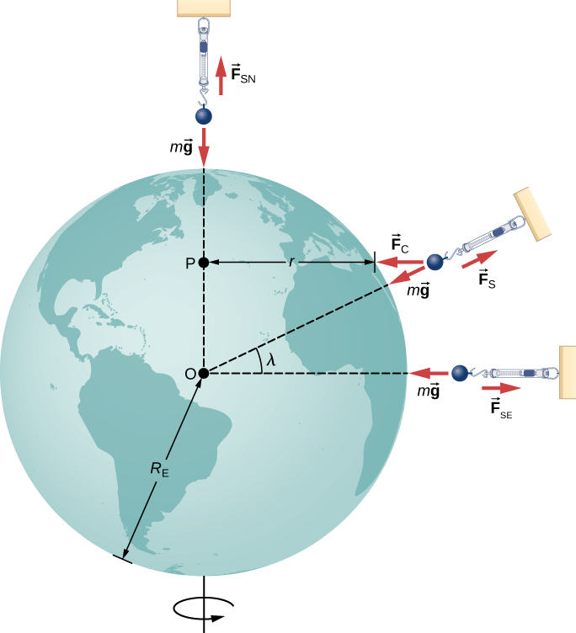

Solution

The free body diagram is shown below.

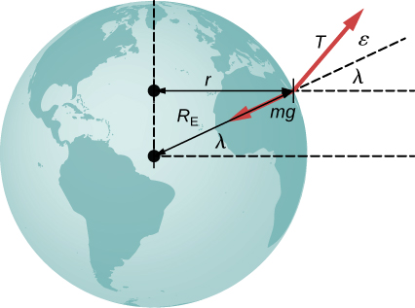

The sum of forces equations are 

and the expression for the deflection angle can be obtained by moving the terms with *T* on one side and dividing. At latitude 45 degrees, with ,  we get  and hence  degrees. Note: The issue with the unjustifiable significant digits for g is best resolved by using a binomial expansion for the denominator. So we would have

. The result is the same.

1. (a) Show that tidal force on a small object of mass *m*, defined as the *difference* in the gravitational force that would be exerted on *m* at a distance at the near and the far side of the object, due to the gravitation at a distance *R* from *M*, is given by  where  is the distance between the near and far side and  (b) Assume you are falling feet first into the black hole at the center of our galaxy. It has mass of 4 million solar masses. What would be the difference between the force at your head and your feet at the Schwarzschild radius (event horizon)? Assume your feet and head each have mass 5.0 kg and are 2.0 m apart. Would you survive passing through the event horizon?

Solution

a. Find the difference in force, ;

b. For the case given, using the Schwarzschild radius from a previous problem, we have a tidal force of . This won’t even be noticed!

1. Find the Hohmann transfer velocities,  and , needed for a trip to Mars. Use  to find the circular orbital velocities for Earth and Mars. Using  and the total energy of the ellipse (with semi-major axis *a*), given by  find the velocities at Earth (perihelion) and at Mars (aphelion) required to be on the transfer ellipse. The difference, , at each point is the velocity boost or transfer velocity needed.

Solution

We know that  , so we have  from which we can solve for  and  .

Find the total transfer velocities  and  The numbers at Earth’s and Mars’ orbits are about 3.0 km/s and 2.6 km/s, respectively.

This file is copyright 2016, Rice University. All Rights Reserved.